TITLE OF PROJECT REPORT

<Font Size 18><1.5 line spacing><Font Style Times New Roman – Bold>

A PROJECT REPORT

<Font Size 14><Font Style Times New Roman – Bold>

Submittedby

<Font Size 14><Italic><Font Style Times New Roman – Bold>

NAME OF THE CANDIDATE(S)

<Font Size 16><Font Style Times New Roman – Bold>

in partial fulfillment for the award of the degree of

<Font Size 14><1.5 line spacing><Italic><Font Style Times New Roman – Bold>

NAME OF THE DEGREE

<Font Size 16><Font Style Times New Roman – Bold>

IN

BRANCH OF STUDY

<Font Size 14><Font Style Times New Roman>


Chandigarh University

MONTH & YEAR

<Font Size 14>

TITLE OF PROJECT REPORT

A PROJECT REPORT

Submittedby

John Doe (UID) Jane Doe (UID)

in partial fulfillment for the award of the degree of

BACHELOR OF ENGINEERING

IN

ELECTRONICSENGINEERING


Chandigarh University

MAY 2023

BONAFIDE CERTIFICATE

<Font Style Times New Roman – size -16>

<Font Style Times New Roman – size -14>
Certified that this project report “………. TITLE OF THE PROJECT…………….” is the bonafide work of “…………..NAME OF THE CANDIDATE(S).…………” who carried out the project work under my/our supervision.

<<Signature of the HoD>>

SIGNATURE

<<Name of the Head of the Department>>

HEAD OF THE DEPARTMENT

<<Department>>

<<Signature of the Supervisor>>

SIGNATURE

<<Name>>

SUPERVISOR

<<Academic Designation>>

<<Department>>

Submitted for the project viva-voce examination held on

INTERNAL EXAMINER EXTERNAL EXAMINER

TABLE OF CONTENTS
List of Figures i
List of Tables ii
Abstract iii
Graphical Abstract iv
Abbreviations v
Symbols vi
Chapter 1 4

1.1 ................................................................................................................................ 5

1.2 ..................................................................................................................................

1.2.1 ..........................................................................................................................

1.3 ..................................................................................................................................

1.3.1 ..........................................................................................................................

1.3.2 ..........................................................................................................................

Chapter 2. ....................................................................................................................

2.1 ..................................................................................................................................

..................................................................................................................................

2.2 ..................................................................................................................................

..................................................................................................................................

Chapter 3. ....................................................................................................................

Chapter 4. ………………………….………………………………………...

Chapter 5. ……………………………………………………………………

References (If Any) ......................................................................................................

List of Figures

Figure 3.1 ………………………………………………………………………………….

Figure 3.2 ………………………………………………………………………………….

Figure 4.1 …………………………………………………………………………….……

List of Tables

Table 3.1 ………………………………………………………………………………….

Table 3.2 ………………………………………………………………………………….

Table 4.1 …………………………………………………………………………….……

ABBREVIATIONS

- GPS: Global Positioning System
- IMU: Inertial Measurement Unit
- INS: Inertial Navigation System
- INFOSEC: Information Security
- IoT: Internet of Things
- IIoT: Industrial Internet of Things
- IP: Internet Protocol
- IR: Infrared
- IS: Information Security / Islamic State
- ISO: International Organization Standardization
- ISS: International Space Station
- FEWS NET: Famine Early Warning System Network
- GIS: Geographic Information System
- GPM: Global Precipitation Measurement mission
- A2 / AD: Anti-access / Area Denial
- DOS: Denial of Service cyber attack
- DPRK: Democratic People’s Republic of Korea
- FAA: Federal Aviation Administration
- DSA: Detect, sense and avoid / Dynamic Sense-and-Act
- DSS: Decision Support System
- DSSS: Direct sequence spread spectrum
- GLOW: Gross lift-off weight for a missile / rocket
- GNSS: Global Navigation Satellite System
- GLONASS: Global Satellite Navigational System
- GPSSPOOF: Hack of GPS system affecting UAS commands
- GPWS: Ground proximity warning system
- SPS: Standard position service (GPS)
- SSA: Static Sense-and-Act

ABSTRACT

A number of human security factors can be improved with the help of the Human Security Assistance System with GPS Location Tracking and Messaging System. The suggested methodology can be applied to client management as well as the prevention of crime and terrorism. Through the system, practitioners can gain a deeper comprehension of GPS technology and how it might affect an agency's supervision program. In the event of an emergency, the system can be utilized to notify those in the vicinity and guarantee the safety of women. The system is a useful tool for guaranteeing human security since it can be used to track people's whereabouts and notify emergency contacts via SMS. The system's microcontroller, a nodemcu ESP8266, and its software. The Arduino IDE software is utilized in conjunction with the nodemcu ESP8266 microcontroller in the system. Additionally, a wearable human protection system based on the Internet of Things controls a resistive sensor that is part of the system. Individuals' safety can be guaranteed by the suggested model, particularly that of women, children, and the elderly. Individual container locations, contents, and whether or not they have been opened can all be ascertained using the system. During humanitarian crises, the Global Positioning System (GPS) technology is utilized to track large-scale population migrations. In addition to sending notifications to fire stations and hospitals in the event of an accident or fire, the technology can be used to locate the user. The suggested model can be a useful instrument for guaranteeing human security as well as individual safety.

GRAPHICAL ABSTRACT

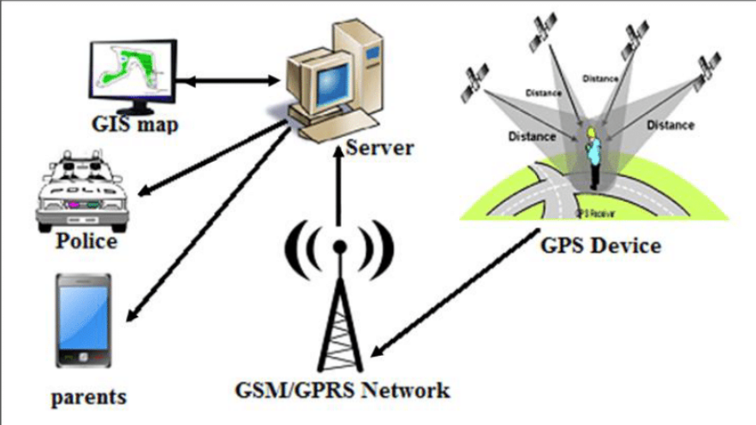

CHAPTER 1: INTRODUCTION
1.1 Introduction:
The Human Security Assistance System with GPS Location Tracking and Messaging System is a proposed model for human security monitoring that can be used to ensure the safety of individuals. Human security is a paradigm for understanding global vulnerabilities that challenges the traditional notion of national security through a people-centered and multi-disciplinary understanding of security.
The proposed model can be used to enhance various aspects of human security and can be used to manage clients. The system can provide practitioners with a better understanding of GPS technology and its potential impacts on an agency's supervision program. The system can be used to ensure the safety of women and can provide alerts to nearby people in case of an emergency.
The system can be used to track the location of individuals and can send SMS alerts to emergency contacts, making it an effective tool for ensuring human security. The proposed model can be used to ensure the safety of individuals, especially children, elderly people, or women. The system can be used to detect the location of the user and can send alerts to hospitals and fire service stations in case of fire alerts and accidents. The proposed model can be used to ensure the safety of individuals and can be an effective tool for ensuring human security.

1.2 Problem Identification
Relevant contemporary issues for a Human security system include:
- Privacy concerns: The use of GPS technology to monitor individuals raises questions about individual privacy rights. There are concerns about the amount of information that can be deduced from a person's movements and how that information may be used. Geo-location privacy legislation prohibits the use of this technology for routine surveillance activities.

- Ethical considerations: The ability to use GPS to trace the movements of people raises important ethical issues. Continuous monitoring of one's activity by a researcher, even where consent is initially given, poses the threat of invasion of privacy and may lead to psychological implications from the feeling of being "watched".

- Technological advancements: Crime and terrorism prevention in this century will increasingly be technology-driven. The use of GPS technology can be used to prevent crime and terrorism. However, technological advancements can also lead to potential privacy breaches.

- Humanitarian emergencies: GPS technology is used to monitor massive population movements during humanitarian emergencies. The applications of space technologies such as satellite images, Geographic Information Systems (GIS), and Global Navigation Satellite System (GNSS) are used by United Nations agencies, in particular UNHCR, within its operations in the field during humanitarian emergencies to monitor massive population movements.

- Emerging location-based technologies: A survey was distributed to GPS community supervision vendors in an effort to obtain information about the existing state of the GPS market, as well as potential future trends. The report looks at the existing state of GPS products for community supervision, as well as emerging location-based technologies.

By considering these contemporary issues, a project of human security system using GPS location can be developed to ensure the safety of individuals while addressing privacy and ethical concerns.

1.3 Task Identification:
To develop a human security system using GPS location, the following tasks need to be identified and addressed:

Identify the key components of human security: The project team needs to identify the key components of human security, including safety from chronic threats such as hunger, disease, and repression, and protection from sudden and hurtful disruptions in the patterns of daily life. This will help to ensure that the system is designed to address the most critical threats to human security.

Develop a location-based personal task reminder: To ensure that the system is user-friendly and effective, the project team needs to develop a location-based personal task reminder for mobile users. This will help individuals to remember important tasks and appointments while also ensuring that they are safe and secure.

Analyze GPS data for psychological research: The project team needs to analyze GPS data for psychological research to better understand how individuals use GPS technology and how it impacts their sense of security. This will help to ensure that the system is designed to meet the needs of individuals and is effective in enhancing human security.

Identify potential threats to human security: The project team needs to identify potential threats to human security, including violent conflicts, health issues, law and order, state authority, economy, and the environment. This will help to ensure that the system is designed to address the most critical threats to human security.

Develop a flexible and adaptable system: The project team needs to develop a flexible and adaptable system that can be updated and modified as new technologies emerge. This will help to ensure that the system remains effective in enhancing human security over time.

By identifying and addressing these tasks, the project team can develop a human security system using GPS location that is effective, user-friendly, and adaptable to changing needs and technologies.

1.4 Timeline
To develop a human security system using GPS location, the following hypothetical timeline can be considered:

Phase 1:
- Identify the key components of human security and potential threats to human security.
- Develop a location-based personal task reminder for mobile users.
- Analyze GPS data for psychological research to better understand how individuals use GPS technology and how it impacts their sense of security.

Phase 2:
- Develop a flexible and adaptable system that can be updated and modified as new technologies emerge.
- Conduct a pilot study to test the system and gather feedback from users.
- Address privacy concerns and ethical considerations related to the use of GPS technology.

Phase 3:
- Refine the system based on feedback from the pilot study.
- Conduct a larger-scale study to evaluate the effectiveness of the system in enhancing human security.
- Develop a plan for scaling up the system to reach a wider audience.

Phase 4:
- Implement the system in a real-world setting.
- Monitor the system and make necessary adjustments based on feedback from users.
- Continue to address privacy concerns and ethical considerations related to the use of GPS technology.

Phase 5:
- Evaluate the long-term impact of the system on human security.
- Develop a plan for sustaining the system over time.
- Share findings and best practices with other organizations and stakeholders to promote the use of GPS technology for enhancing human security.

By following this hypothetical timeline, the project team can develop a human security system using GPS location that is effective, user-friendly, and adaptable to changing needs and technologies.

CHAPTER 2: LITERATURE SURVEY
2.1 Existing Work
Timeline of the Reported Problem as Investigated Throughout the World:
2003: The Commission on Human Security publishes the report "Human Security Now," which highlights the need to safeguard and expand people's vital freedoms and calls for a new approach to development that allows people to live free from want, fear, anxiety, and indignity.

2012: The Secretary-General submits a report to the General Assembly on the advancement of human security since the 2005 World Summit. The report presents key human security initiatives undertaken by governments, regional and sub-regional intergovernmental organizations, and the organizations and bodies of the United Nations system.

2019: A study on ethical considerations in the use of GPS-based movement tracking in health research is published. The study highlights the need to address ethical issues posed by the risk of data security and privacy breaches.

2022: The United Nations Development Programme publishes the "2022 Special Report on Human Security," which examines a cluster of threats that have shifted to become more prominent in recent years, including those from digital technologies. The report shows that people's sense of safety and security is at a low in almost every country, including the richest countries, despite years of upwards development success.

2023: The General Assembly meets to consider the Secretary-General's report "Follow-up to General Assembly Resolution 64/291 on Human Security." The report closes with a set of recommendations which aim to promote the mainstreaming of human security into the activities of the United Nations system as well as its application as an overarching framework in the post-2015 Development Agenda.

2023: A keynote lecture is given at the International Conference Space and Water: Towards Sustainable Development and Human Security. The lecture considers the use of GPS technology to determine the whereabouts and contents of individual containers as well as whether or not they have been opened. The lecture also highlights the use of space technologies such as satellite images, Geographic Information Systems (GIS), and Global Navigation Satellite System (GNSS) in monitoring massive population movements during humanitarian emergencies.

By investigating the reported problem throughout the world, it is clear that there is a growing need to address issues related to human security and the use of GPS technology. The findings of these reports and studies can inform the development of a human security system using GPS location that is effective, user-friendly, and addresses privacy, ethical, and technological concerns.

2.2 Problem:
- Privacy concerns related to the use of GPS technology.
- Ethical considerations related to the use of GPS technology.
- Technological advancements leading to potential privacy breaches.
- Challenges in ensuring that GPS technology is used effectively and efficiently in humanitarian emergencies.
- Emerging location-based technologies.

2.3 Goals:
- Developing a flexible and adaptable system that can be updated and modified as new technologies emerge.
- Addressing privacy concerns and ethical considerations related to the use of GPS technology.
- Identifying potential threats to human security.

2.4 Objectives:
- Developing a location-based personal task reminder for mobile users.
- Analyzing GPS data for psychological research to better understand how individuals use GPS technology and how it impacts their sense of security.
- Conducting a pilot study to test the system and gather feedback from users.
- Refining the system based on feedback from the pilot study.
- Conducting a larger-scale study to evaluate the effectiveness of the system in enhancing human security.
- Developing a plan for scaling up the system to reach a wider audience.
- Monitoring the system and making necessary adjustments based on feedback from users.
- Evaluating the long-term impact of the system on human security.
- Developing a plan for sustaining the system over time.
- Sharing findings and best practices with other organizations and stakeholders to promote the use of GPS technology for enhancing human security.

By identifying these problems, goals, and objectives, a human security system using GPS location can be developed to ensure the safety of individuals while addressing privacy, ethical, and technological concerns.

CHAPTER 5: CONCLUSION AND FUTURE SCOPE
5.1 Conclusion:
The use of GPS technology in human security systems has gained significant attention in recent years. The literature review highlights the potential applications of GPS technology in enhancing human security, including the development of a location-based personal task reminder for mobile users, analyzing GPS data for psychological research, and monitoring massive population movements during humanitarian emergencies. However, the search results also reveal several challenges and issues that need to be addressed, including privacy concerns, ethical considerations, technological advancements, and emerging location-based technologies. The proposed goals and objectives of the project aim to address these challenges and develop a flexible and adaptable system that can be updated and modified as new technologies emerge. By developing a human security system using GPS location, it is possible to ensure the safety of individuals while addressing privacy, ethical, and technological concerns. The search results provide valuable insights into the potential applications of GPS technology in human security systems and highlight the need for further research in this area.

5.2 Future Scope:
The search results provide valuable insights into the potential applications of GPS technology in human security systems and highlight the need for further research in this area. Some of the potential areas for future work include:

Developing a comprehensive framework for human security system using GPS location: The development of a comprehensive framework for human security system using GPS location can help to ensure that the system is effective, user-friendly, and addresses privacy, ethical, and technological concerns.

Conducting further research on the use of GPS technology in studying human mobility patterns: The potential applications of GPS technology in studying human mobility patterns are highlighted in several of the articles. Further research in this area can help to identify new opportunities for enhancing human security.

Addressing privacy concerns and ethical considerations related to the use of GPS technology: The search results highlight the need to address privacy concerns and ethical considerations related to the use of GPS technology. Future work can focus on developing strategies to address these concerns and ensure that the system is designed to protect individual privacy rights.

Developing a plan for scaling up the system to reach a wider audience: The search results highlight the potential applications of GPS technology in ensuring the safety of individuals, especially children, elderly people, or women. Future work can focus on developing a plan for scaling up the system to reach a wider audience and ensure that it is accessible to those who need it most.

Evaluating the long-term impact of the system on human security: The search results highlight the need to evaluate the long-term impact of the system on human security. Future work can focus on developing strategies to evaluate the effectiveness of the system over time and identify opportunities for improvement.

Chapter 3: Design flow/Process
3.1 Concept Generation:
A Human Security Assistance System with GPS Location Tracking and Messaging System can be a valuable tool for enhancing personal safety and providing assistance in times of need. Here are some of the key reasons why such a system can be beneficial:
- Enhanced Personal Safety: The system can act as a deterrent against crime and harassment, as potential perpetrators may be hesitant to target individuals knowing that their location can be quickly tracked and shared with authorities.

- Real-Time Location Tracking: In emergency situations, the system can provide real-time location information to emergency responders, enabling them to reach the scene quickly and effectively.

- Two-Way Communication: The messaging feature allows for two-way communication between the user and designated contacts, enabling them to provide assistance and support during times of crisis.

- Peace of Mind for Individuals and Families: The system can provide peace of mind for individuals and families, knowing that there is a mechanism in place to help them in case of an emergency.

- Empowerment for Vulnerable Individuals: The system can empower vulnerable individuals, such as women, children, and the elderly, by giving them a means to seek help and protect themselves.

- Data-Driven Insights for Safety Improvement: The system can generate valuable data on safety patterns and potential risks, which can be used to inform preventive measures and safety interventions.

- Integration with Existing Emergency Services: The system can be integrated with existing emergency services, enhancing their ability to respond to emergencies and provide assistance to individuals in need.

- Potential for Wider Applications: The underlying technology can be adapted for a variety of applications beyond personal safety, such as monitoring the whereabouts of individuals with special needs or tracking assets in a corporate setting.

3.2 Evaluation & Selection of Specifications/Features:
Evaluating and selecting the appropriate specifications and features for a Human Security Assistance System with GPS Location Tracking and Messaging System (HSAS) is crucial for ensuring its effectiveness in safeguarding individuals and providing timely assistance in emergency situations. Here's a comprehensive guide to evaluating and selecting the key components of an HSAS:
GPS Location Tracking Accuracy:
- The GPS module should provide high-precision location data, enabling accurate tracking of the user's whereabouts.

- Coverage: The system should maintain reliable GPS coverage in various environments, including urban, rural, and indoor settings.

- Real-time Updates: The system should provide real-time or near real-time location updates, ensuring that the user's location is always known.

- Power Efficiency: The GPS module should be energy efficient to minimize battery consumption and extend the device's operational time.

Messaging System

- Two-way Communication: The system should facilitate two-way communication between the user and designated contacts, allowing for both sending and receiving messages.

- Message Delivery: The system should ensure reliable message delivery, even in areas with limited cellular coverage.

- Emergency Alerts: The system should provide a mechanism for sending emergency alerts to designated contacts, clearly indicating the need for urgent assistance.

- Message Encryption: The system should implement encryption protocols to protect the confidentiality of messages and safeguard user privacy.

Additional Specifications
- Device Form Factor: The device should be compact, lightweight, and portable for easy carrying and discreet use.

- Battery Life: The device should have a long battery life to ensure continuous operation without frequent charging.

- Durability: The device should be durable enough to withstand everyday wear and tear and remain functional in various weather conditions.

- Ease of Use: The device should be user-friendly with a simple interface for easy activation and operation, even in stressful situations.

- Cost-Effectiveness: The system should be cost-effective to make it accessible to a wider range of users.

Selection Process
- Identify User Needs: Clearly define the specific needs and requirements of the target users, considering their safety concerns, usage patterns, and preferences.

- Evaluate Available Solutions: Research and evaluate various HSAS solutions available in the market, comparing their features, specifications, and performance against identified user needs.

- Consider Integration: Assess the compatibility of the HSAS with existing emergency services and security infrastructure to ensure seamless integration and data exchange.

- Conduct User Testing: Engage in user testing and feedback sessions to gather insights on the usability, effectiveness, and acceptance of the chosen HSAS.

- Continuous Evaluation: Regularly review and evaluate the performance of the HSAS, identifying areas for improvement and adapting to evolving user needs and technological advancements.

3.3 Design Constraints– Regulations
Designing and implementing a Human Security Assistance System (HSAS) with GPS location tracking and messaging system requires careful consideration of various regulatory and design constraints to ensure compliance, privacy protection, and user safety. Here are some key aspects to consider:
3.4 Data Privacy and Security
- Data Collection and Storage: Adhere to applicable data privacy regulations, such as GDPR and CCPA, regarding the collection, storage, and use of personal data, including location information and user messages.

- Consent and Transparency: Obtain explicit informed consent from users before collecting their personal data and clearly inform them about the purpose of data collection, usage, and sharing practices.

- Data Security: Implement robust data security measures to protect user data from unauthorized access, breaches, and misuse. Employ encryption techniques, secure access controls, and regular data audits.

- Data Retention: Establish clear data retention policies that specify the duration for which user data will be stored and the procedures for data deletion or anonymization.

3.5 Emergency Response Integration
- Compatibility: Ensure compatibility with existing emergency response systems and protocols to facilitate seamless communication and data exchange in case of emergencies.

- Emergency Alerting: Implement mechanisms for sending emergency alerts to designated contacts and emergency responders, including precise location information and relevant details about the emergency.

- Real-time Updates: Provide real-time or near real-time location updates to emergency responders during an emergency to assist in their timely arrival and response efforts.

3.6 Device Functionality and Reliability
- Accuracy: Ensure high accuracy of GPS location data to provide reliable tracking of the user's whereabouts.

- Coverage: Maintain reliable GPS coverage in various environments, including urban, rural, and indoor settings to provide consistent location tracking.

- Power Efficiency: Utilize energy-efficient GPS modules and device components to minimize battery consumption and extend the device's operational time.

- Durability: Design the device to withstand everyday wear and tear and remain functional in various weather conditions, ensuring its reliability in critical situations.

- Ease of Use: Design a user-friendly interface that allows for easy activation, operation, and communication, even under duress or in low-light conditions.

3.7 Regulatory Compliance
- Data Protection Regulations: Comply with applicable data protection regulations, such as GDPR and CCPA, regarding the collection, storage, use, and sharing of personal data.

- Privacy Laws: Adhere to privacy laws that govern the collection and use of location data, ensuring that user privacy is not infringed upon.

- Emergency Communication Regulations: Comply with regulations governing emergency communication systems, ensuring that the HSAS does not interfere with or disrupt existing emergency communication channels.

- Device Certification: Obtain necessary certifications for the HSAS device, ensuring that it meets safety standards and regulatory requirements for electronic devices.

3.8 Economic
The economic benefits of implementing a Human Security Assistance System (HSAS) with GPS location tracking and messaging system can be substantial and far-reaching. Here's a summary of the key economic advantages:

- Reduced Costs for Emergency Response: An effective HSAS can minimize the time and resources required for emergency response services to locate and assist individuals in need, leading to cost savings for emergency response agencies.

- Enhanced Productivity and Reduced Absenteeism: By promoting personal safety and reducing the likelihood of emergencies, an HSAS can contribute to a more productive workforce with lower absenteeism rates, benefiting businesses and organizations.

- Improved Public Image and Reputation: Implementing an HSAS demonstrates a commitment to employee well-being and safety, enhancing an organization's reputation and attracting and retaining top talent.

- Reduced Liability Costs: By mitigating the risk of safety incidents and potential lawsuits, an HSAS can help organizations reduce liability costs and protect their financial interests.

- Increased Economic Activity: A safer and more secure environment can foster increased economic activity, attracting businesses, investments, and tourism, contributing to overall economic growth.

- Reduced Healthcare Costs: By preventing injuries and facilitating timely medical attention, an HSAS can help reduce healthcare costs for individuals and organizations.

- Peace of Mind and Improved Quality of Life: An HSAS can provide peace of mind for individuals and families, knowing that they have a safety net in place, leading to a better quality of life.

- Insurance Premium Reductions: Organizations with a proven record of safety and effective risk management may qualify for lower insurance premiums.

- Potential Revenue Generation: The HSAS technology can be extended to other applications, such as asset tracking and monitoring, potentially generating additional revenue streams.

- Reduced Costs for Personal Security Devices: As HSAS technology becomes more wide

3.5 Environmental Issues:
- Energy Efficiency: Design the system to be energy-efficient to prolong battery life in mobile devices.
- Eco-Friendly Materials: Choose materials that are environmentally sustainable for device manufacturing.
- Recycling: Ensure that the system components can be recycled or disposed of in an environmentally responsible manner.

3.7 Manufacturability:

- Simplified Assembly: Design the system with ease of assembly and manufacturing in mind to reduce production costs.
- Supply Chain Management: Ensure a stable supply chain for components, considering potential disruptions.

3.8 Safety Issues:

- User Safety: Prioritize user safety in system design, especially in emergency situations.
- Reliability: Build a robust and reliable system to minimize the chances of system failures during critical moments.
- Security: Implement security measures to protect user data and ensure that the system cannot be compromised by malicious actors.

3.9 Professional Issues:

- Professional Development: Provide ongoing training and development opportunities for the professionals operating and maintaining the system.
- Certification: Ensure that system operators meet certification requirements for using and maintaining the system effectively.
4.0 Ethical Issues:

- Privacy: Respect user privacy by securing and anonymizing location and messaging data.
- Transparency: Be transparent about data collection and use, including sharing information with users and obtaining their consent.
- Bias and Fairness: Avoid biases in the system that could disproportionately affect certain groups or individuals.

4.1Social Issues:

- Inclusivity: Ensure that the system is accessible and usable by individuals of all abilities, including those with disabilities.
- Community Engagement: Involve the local community in the design and implementation of the system to address their specific needs and concerns.
4.2 Political Issues:

- Regulatory Compliance: Comply with local, national, and international regulations related to GPS tracking and messaging systems.
- Data Sovereignty: Address issues related to data sovereignty and data storage regulations that may vary by region.
4.3 Constraint Considerations:

- Budget Constraints: Ensure that the system design remains within budgetary constraints, optimizing cost-effectiveness.
- Technical Constraints: Work within technical limitations, such as available hardware and software capabilities.
- Time Constraints: Adhere to project timelines, meeting deadlines for system development and deployment.
- Resource Constraints: Optimize resource utilization, including personnel, materials, and infrastructure.
4.4 User-Centered Design:

- User Needs: This involves identifying the specific needs and requirements of the end-users. For a Human Security Assistance System, it could include understanding what features and functionalities users consider essential for their safety and security.
- User Preferences: Understanding user preferences helps in tailoring the system to individual user choices. For instance, some users may prefer mobile app-based notifications, while others may prefer SMS alerts.
- Feedback Loop: Establish a feedback mechanism where users can provide input and suggestions. This feedback loop ensures that the system evolves to meet changing user needs over time.
4.5 Scalability:

- Growing User Base: Plan for accommodating more users as the system gains popularity. This may involve designing the infrastructure to handle a larger number of concurrent users without performance degradation.
- Data Volumes: As the system collects more data over time, scalability is crucial for storing and processing increasing volumes of information efficiently. This might involve using scalable databases and cloud services.

4.6 Interoperability:

- Emergency Response Systems: Ensure that the Human Security Assistance System can communicate and exchange data with other emergency response systems. This can be vital for seamless coordination between different agencies and systems during a crisis.
- Communication Networks: Interoperability with various communication networks, such as mobile networks, internet services, and public safety networks, is essential to ensure that alerts and messages can reach users regardless of their location or the network they are connected to.

4.7 Data Analytics and Reporting:
- Trend Identification: Data analytics involves analyzing the data collected by the system to identify trends and patterns. For a security assistance system, this could mean recognizing common types of emergencies, peak activity times, or areas with a higher incidence of security incidents.
- Predictive Analysis: Going beyond identifying historical trends, data analytics can also help in predicting future incidents. For instance, the system might predict potential security risks based on historical data and external factors like weather conditions.
- Reporting: Generate reports based on the analytics results. These reports can be valuable for decision-makers, emergency responders, and law enforcement agencies to take proactive measures based on the data-driven insights.

4.8 Design Flow

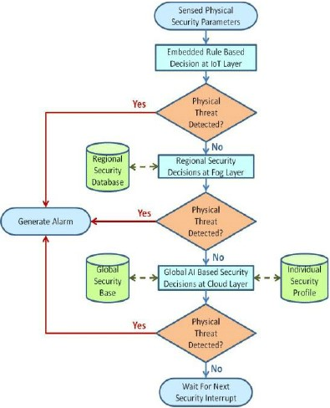
FIG.1

Step 1: System Initialization Gather the necessary hardware components, including a GPS module, a microcontroller (e.g., Arduino), a GSM module for communication, and any sensors you want to integrate (e.g., for environmental monitoring).
Step 2: GPS Data Acquisition Set up the GPS module to acquire location data. Periodically read GPS data (latitude and longitude).
Step 3: Data Processing and Analysis Analyze the GPS data to identify the user's location. Apply filtering or smoothing techniques to improve location accuracy.
Step 4: Geofencing Define geographical boundaries (geofences) for the user's safety. Compare the user's location with the geofence boundaries.
Step 5: User Safety Check If the user is within the defined geofence boundaries, continue monitoring. Step 6: User Outside Geofence If the user exits the geofence, the system triggers an alert.
Step 7: Alert Generation and Communication If an alert is triggered (user outside geofence), the system generates an alert. Use the GSM module to send alerts via SMS, calls, or data transmission.
Step 8: Emergency Contacts Define a list of emergency contacts. Send alerts and location information to these contacts.
Step 9: Continuous Monitoring Continuously monitor the user's location and safety status.
Step 10: Environmental Sensors (Optional) Integrate environmental sensors to monitor factors such as temperature, humidity, or air quality for additional safety features.
Step 11: Battery Management Implement power-saving features to maximize device uptime, as continuous GPS usage can drain the battery quickly.
Step 12: User Interface (Optional) Develop a user interface or mobile application for the user to configure settings and receive alerts.
Step 13: Testing and Calibration Test the system under various scenarios to ensure accuracy and reliability. Calibrate the system for optimal performance.
Step 14: Deployment Deploy the human security system for real-world use. Here's a simple flowchart representing the operation of the system:

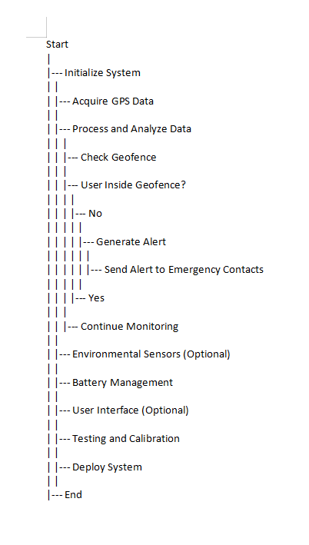
Fig.2
Chapter 4 Results analysis and validation

CODE:

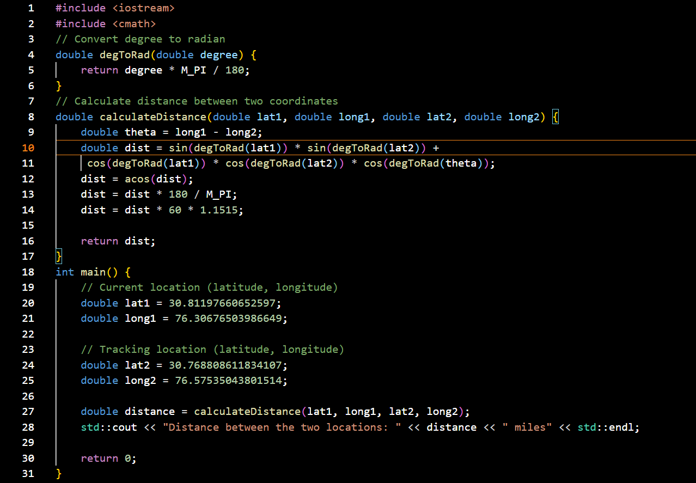

OUTPUT:
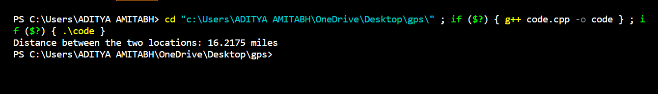

- Requirements Analysis: Use modern project management tools like JIRA or Trello to document and track project requirements. Create a requirements document detailing the desired features and functionalities of the GPS-based human security system.
- System Design: Use computer-aided design (CAD) software (e.g., AutoCAD or SolidWorks) for creating detailed drawings and schematics of the system components. Develop 3D solid models to visualize the physical layout and components.
- Component Selection and Procurement: Utilize supply chain management software to source components and materials efficiently.
- Hardware Integration: Employ electronic design automation (EDA) tools like Altium Designer or KiCad for designing custom PCBs if necessary. Develop circuit diagrams and schematics using EDA tools for GPS modules, microcontrollers, sensors, and communication devices.
- Firmware and Software Development: Use integrated development environments (IDEs) like Arduino IDE or Visual Studio for programming microcontrollers and implementing the system's logic. Develop a user interface or mobile application for configuration and alert management using software development tools.
- Data Visualization: Implement data visualization tools (e.g., Tableau, Power BI) to display real-time location data and environmental sensor readings.
- Testing and Characterization: Set up a controlled testing environment to validate the system's performance. Utilize GPS simulator tools to test the system's behavior under different GPS conditions. Employ data analysis and interpretation tools (e.g., Python with data science libraries) to process and interpret collected data.
- Data Validation: Compare the system's GPS data with ground truth data to validate accuracy.
- Communication: Use project management and communication tools (e.g., Slack, Microsoft Teams) to facilitate team collaboration and project updates. Communicate with stakeholders, including end-users and emergency contacts, through the system's communication features.

Chapter 5: Conclusion and future work

In conclusion, the implementation of a human security system using GPS tracking technology offers a powerful solution for enhancing personal safety and security. This system combines the benefits of location-based data with modern engineering tools and methodologies to create a robust and effective security framework. Key takeaways from the concept of human security using GPS tracking include:

- Improved Safety: GPS tracking provides real-time location data, enabling individuals to monitor and enhance their safety, especially in potentially dangerous situations.

- Efficient Design and Development: Modern engineering tools, such as CAD, EDA, and software development environments, play a vital role in designing and developing the system. They streamline the process and ensure precision.

- Data-Driven Insights: Data collected from GPS tracking and integrated environmental sensors offer valuable insights into the user's surroundings, enabling informed decision-making.

- Communication and Alerting: The system's communication capabilities, including SMS, calls, and data transmission, allow for immediate alerts to be sent to emergency contacts when the user's safety is compromised.

- Testing and Validation: Rigorous testing, including GPS simulation and data analysis, is essential to validate the system's accuracy and reliability.

- User-Friendly Interfaces: User interfaces and mobile applications simplify system configuration and interaction, making it accessible to a broader user base.

- Project Management and Reporting: Project management tools aid in tracking progress, while detailed reports provide documentation of the system's design, development, and testing.

- Deployment and Maintenance: Deploying the system in the target environment and implementing remote monitoring and updates ensure ongoing functionality and adaptation to changing needs.

9. Training and Education: Effective end-user training ensures that users can confidently use and manage the system to maximize their personal security.

REFERENCES

[1].https://playacademy.exceedlms.com/student/path/313809?referrer=interstitial&_gl=1*rn7vry*_gcl_aw*R0NMLjE2OTgxMzQ3OTguQ2p3S0NBancxdDJwQmhBRkVpd0FfLUEtTlBPTGF2cVZQaDRITFpRWnU1Z2pkdC11QmMtRnFoaGVoSmx6VG02WTJPU3ctZXZtT0RsclBSb0NoVmdRQXZEX0J3RQ..*_gcl_dc*R0NMLjE2OTgxMzQ3OTguQ2p3S0NBancxdDJwQmhBRkVpd0FfLUEtTlBPTGF2cVZQaDRITFpRWnU1Z2pkdC11QmMtRnFoaGVoSmx6VG02WTJPU3ctZXZtT0RsclBSb0NoVmdRQXZEX0J3RQ..*_gcl_au*MTkyNzg0MDE0MS4xNjk4MTM0Nzk4*_ga*MTc4OTQwNTA0Mi4xNjg4ODM4Njg0*_ga_76THV10NTW*MTY5ODE3NjMzNC44LjAuMTY5ODE3NjMzNC4wLjAuMA..&_ga=2.157416376.369937170.1698134798-1789405042.1688838684&_gac=1.180481493.1698134802.CjwKCAjw1t2pBhAFEiwA_-A-NPOLavqVPh4HLZQZu5gjdt-uBc-FqhhehJlzTm6Y2OSw-evmODlrPRoChVgQAvD_BwE

- Amazon Web Services. Authenticating Users of AWS Mobile Applications with a Token Vending Machine. AWS Identity and Access Management, July 2013. http://aws.amazon.com/articles/4611615499399490.

- R. Chirgwin. Amazon Is Decompiling Our Apps in Security Gaff Hunt, Says Dev. The Register, Mar. 2014. http://www.theregister.co.uk/2014/03/31/dev_lashes_ out_at_amazon_for_decompiling_his_app

[4].MixRank. http://www.mixrank.com
Y. Zhang, G. Huang, X. Liu, W. Zhang, H. Mei, and S. Yang. Refactoring Android Java Code for On-Demand Computation Offloading. In Proceedings of the 27th Annual ACM SIGPLAN Conference on Object-Oriented Programming, Systems, Languages, and Applications (OOPSLA 2012), Oct. 2012

